Starting Jupyter Notebook

Enter Servers 4-6; and select anaconda prompt

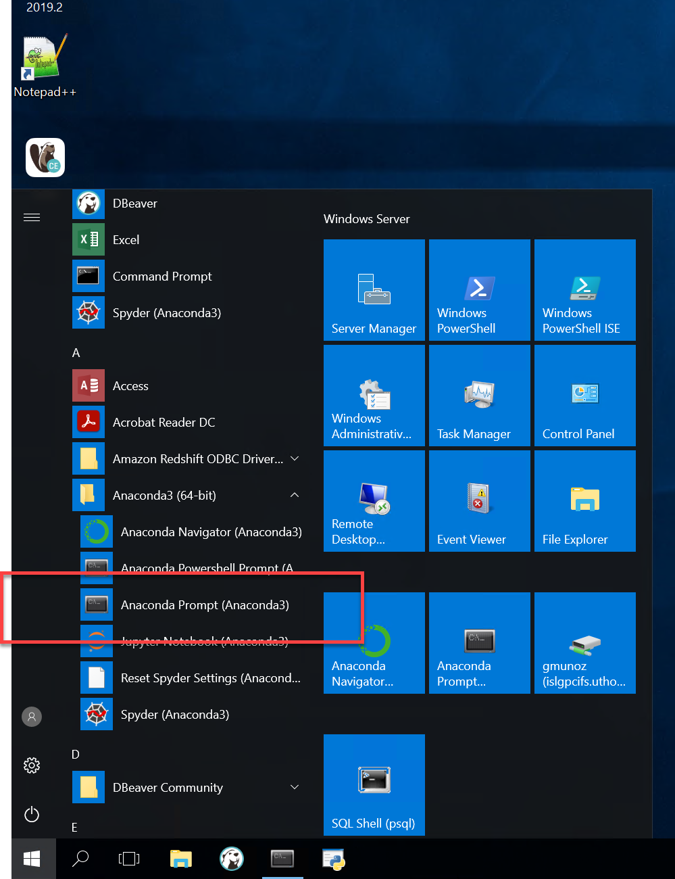

This will open a console; to initiate jupyter notebook type

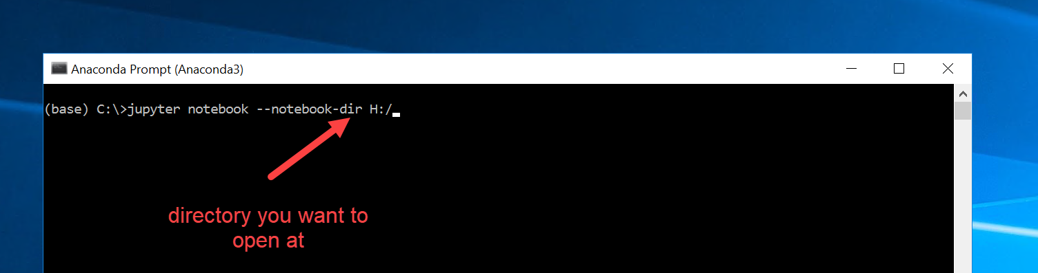

This will initiate a browser and you will see something like below. You can then access notebooks or make a new notebook.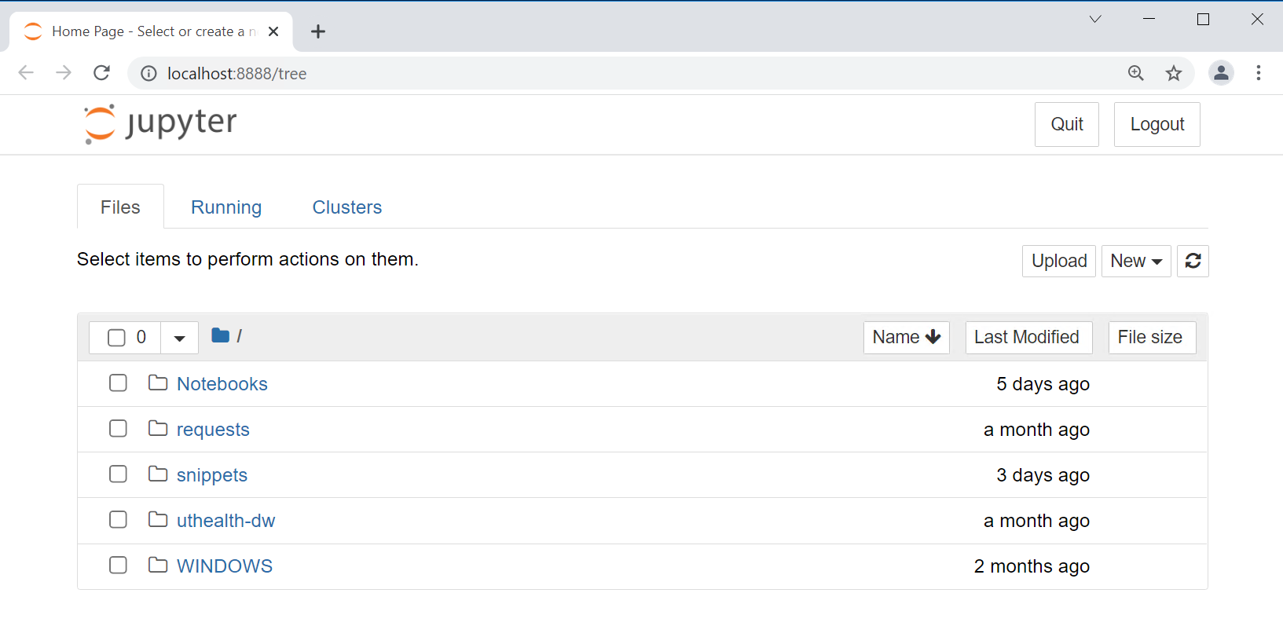

To connect to a database from python securely it is imperative you use the ODBC Data Source Administrator. Create a UserDSN.